Models Exercise 2: Lumped Conceptual Model

Considering the following conceptual model:
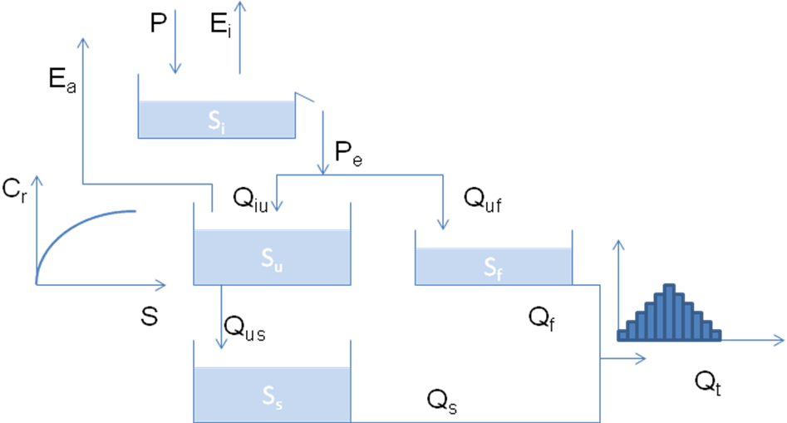

- Write the water balance of model components
- Determine the units of model parameters
- Code the model in Matlab or Python
- Find an appropriate parameter set by trial and error
- Understand the effect of model parameters on the hydrograph
Water can evaporate from the interception reservoir at the potential rate E_{p}. Water can spill from the reservoir when the level S_{i} reaches I_{max} (mm) (see lecture slides). P_{e} is partitioned into P_{i} and P_{f} according to C_{r}, calculated as C_{r}=(S_{u}/S_{umax})^beta. Q_{uf}=C_{r}*P_{e}; Q_{iu}=(1-C_{r})*P_{e}. E_{a}=S_{u}/(S_{umax}*C_{e})*E_{p}; Q_{us}=P_{max}*(S_{u}/S_{umax}); Q_{f}=K_{f}*S_{f}; Q_{s}=K_{s*}S_{s}. Q_{f} and Q_{s} are summed and routed through the triangular transfer function with base T_{lag}.
Model parameters are I_{max}, C_{e}, S_{umax}, beta, P_{max}, K_{f}, K_{s}, T_{lag}.
The supplied forcing file contains Rainfall (P), Discharge (Q) and Potential evaporation (E_{p}) time series in mm/h

